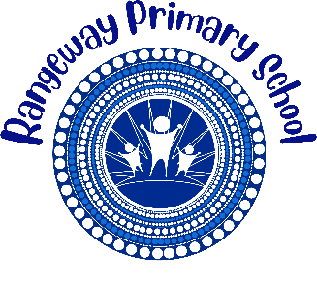
Rangeway Primary School

2026 BOOK LIST

Year 1& 2

Dear Parent/Carer, please find below booklist for your child in 2026.
We do not have a preferred supplier. Please source the stationery items from various news agencies, stationery stores and supermarkets.

YEAR 1& 2 Book List

No. | Item | Estimated Cost
1 | Paper towel (2 pk) | $2.00
2 | Tissue box | $3.80
1 | Eraser (2 pk) | $1.00
1 | Glue stick | $2.00
1 | Lead pencils (6 pk) | $1.00
1 | Coloured pencil/crayon | $3.50
1 | School Hat (front office) | $14.00
 | Total | $27.30

Please clearly mark your child’s name on all items

