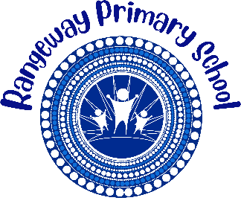
Rangeway Primary School

2026 BOOK LIST

Year 5 & 6
Dear Parent/Carer, please find below booklist for your child in 2026.
We do not have a preferred supplier. Please source the stationery items from various news agencies, stationery stores and supermarkets.

YEAR 5 & 6 Book List

No | Item | Estimated Cost
2 | Tissue box | $3.80
1 | Eraser (2pk) | $1.00
4 | Glue stick | $4.00
1 | Pencil case | $1.00
1 | Pencils\crayons coloured | $3.50
1 | Pencil sharpener | $1.50
1 | Pencil HB (pk6) | $1.00
1 | Plastic ruler 30cm | $1.00
1 | Red pens (2pk) | $1.00
1 | Texta/marker coloured | $3.50
1 | Scissors | $2.00
1 | Library Bag | $3.50
1 | School Hat (front office) | $14.00
 | Total | $35.30

Please clearly mark your child’s name on all items

