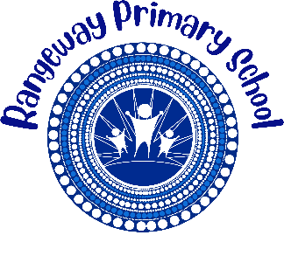
Rangeway Primary School

2026 BOOK LIST

Kindy & Pre primary
Dear Parent/Carer, please find below booklist for your child in 2026.
We do not have a preferred supplier. Please source the stationery items from various news agencies, stationery stores and supermarkets.

Kindy & Pre primary Book List

No | Item | Estimated Cost
1 | Sponges | $1.80
1 | Ziplock Sandwich Bag | $3.15
2 | Chux Magic Erasers | $4.70
1 | Small Paper Plates Pack | $1.50
1 | Large Paper Plates Pack | $3.50
1 | Paper Towel (2 pk) | $2.00
2 | Tissue Box | $3.80
1 | Flour 1kg Bag | $1.30
1 | Salt 1kg Bag | $2.60
1 | School Hat (Front Office) | $14.00
 | Total | $38.35

